Fochabers Public Institute
15 High Street, Fochabers, Moray, IV32 7EP
General enquiries 07843967409 - Bookings 07513194445
Email fochabers.institute@gmail.com – Website http://fochabersinstitute.org
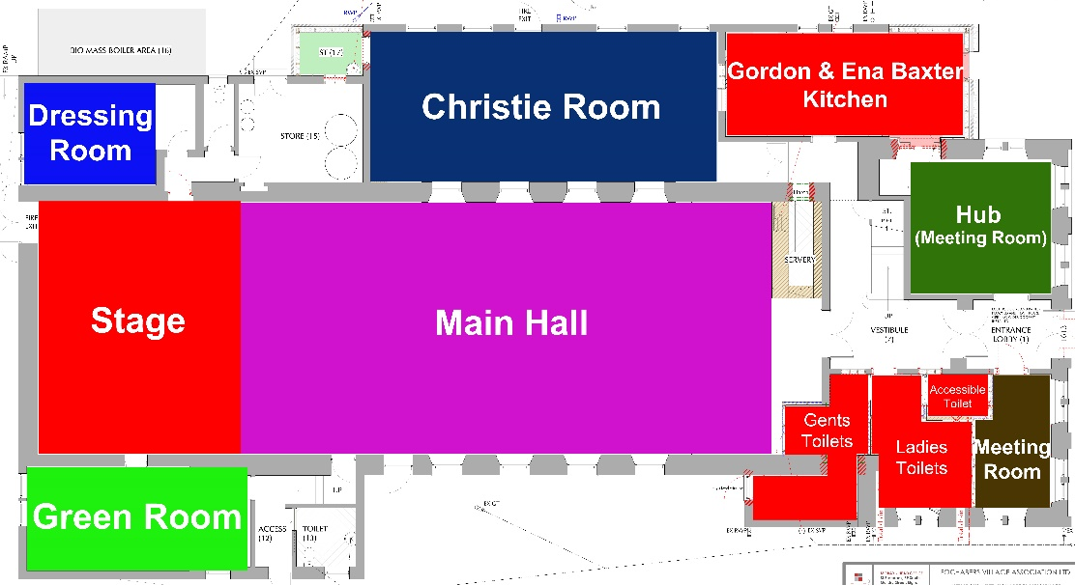

A. Booking charges as of 1st April 2023.
Main Hall £20.00 per hour
Christie room £15.00 per hour
Green room £10.00 per hour
2nd dressing room £10.00 per hour
Hub (Meeting room) £10.00 per hour
Small meeting room £10.00 per hour
Kitchen Full use for catering £50.00
For Coffee Mornings £15.00
All other areas hourly rate please contact the Institute.
All concerts and functions, including parties, weddings, require an all facilities booking.
Full day (including evening) hire all facilities £360.00
Evening hire only all facilities £235.00
All drinks provided, purchased or consumed on the premises must be through facilities provided by the Institute. The above fee includes the cost of applying for a license for the event from Moray Council, which the Institute will apply for on behalf of the hirer. Please note – 30 days notice is required on booking form for anyone requiring bar facilities.
Bring your own bottle events are not permitted on the premises.
All prices include VAT
Please note Fee for hall manager to set up and clear tables and chairs and or portable stage - £25.00
B. Terms and conditions

General Conditions
- For the purpose of these conditions, the term Institute shall mean the Fochabers Public Institute Management Committee.
- For the purpose of these conditions, the term hirer shall mean an individual hirer, or, where the hirer is an organisation, the authorised representative as listed in the Booking Form.
- Hirers are asked to respect the facilities provided by the Institute.
- The hirer shall ensure that the minimum of noise is made on arrival and departure. Hires will terminate at midnight unless dispensation is given in writing in advance.
- The premises shall not be used for public entertainment outside the hours of 9.00am and midnight unless special permission has been given by the Institute.
- The hirer shall ensure that no animals, except guide dogs, are brought into the building, without prior agreement.
- If a representative of Institute is called out to the building during a hire to remedy a situation caused by improper use of the building, then an additional charge may be levied.
- 24 hour CCTV recording operates in and around the premises for the security of staff and visitors.
- Institute management officials are entitled to access any events to ensure conditions are being met and proper order is being maintained.
- An all facilities booking includes the use of professional stage sound and lighting equipment providing the hirer enlists a suitably qualified person to operate it. Any loss or damage will be charged for. The Institute can assist with organising an operator if required (at cost). We can also provide a PA system for the main hall and Christie Room, which is connected to an induction loop system and is included in the hire charge.
- Any hirer using the Kitchen must ensure all individuals are trained and in receipt of the appropriate certification for using the equipment. See Appendix 1
- The Institute reserves the right to amend the Conditions of Hire, Booking Form and schedule of charges at any time.
Booking Procedure
- All bookings must be made through the bookings manager. To book please, email fochabers.institute@gmail.com, telephone 07513194445, or use our on-line booking form available from the Institute website at http://fochabersinstitute.org. For an initial booking, or a single booking, the hirer must complete an on-line application form or return the print version of the form by post to Alan Brown, 9 Institution Road, Fochabers, Moray, IV32 7DZ. The print version will be sent on request or you may download it from the website. At this time, the prospective hirer shall confirm on the booking form that he/she/they accept these Conditions of Hire.
- Bookings are provisional until confirmed in writing by mail or by e-mail.
- The hirer has access only to these parts of the Institute specified on their booking form.
- Payment for hire of the Institute or parts thereof in accordance with the current published Scale of Charges shall be made as follows:
  - All one-off events should be paid in full on receipt of invoice and payment made within 15 days. (see also Cancellation Policy below).
  - For organisations making multiple bookings, i.e. weekly or monthly etc., invoices will be issued at the end of each month and payment made within 15 days.

Cancellation Policy
- In the event that a hirer has to cancel a confirmed booking, a percentage refund of any upfront payment that has been made will be paid in accordance with the following timescales:
  - Weddings:
    - cancellation more than 6 months before the booked date – 90%
    - cancellation between 6 and 3 months before the booked date – 50%
    - cancellation less than 3 months before the booked date – 10%
  - All other one off bookings:
    - cancellation more than 1 month before the booked date – 50%
    - cancellation less than 1 month before the booked date – 10%
  - Multiple bookings: cancellation charges will apply on the same principle as for one-off bookings with a negotiated amount to be agreed according to the circumstances.
- Requests for cancellations are to be submitted by email or in writing.

Hirers' Responsibilities

- The hirer will, during the period of hiring, be responsible for supervision of the premises, the fabric and the contents, their care, safety from damage and the behaviour of all persons using the premises, whatever their capacity. Children are not permitted in the kitchen.
- The hirer shall not use the premises for any purpose other than that described in the hire agreement and shall not sub-hire or use the premises or allow the premises to be used for any unlawful purpose or in any unlawful way nor do anything to bring onto the premises anything which may endanger the same or render invalid any insurance policies in respect thereof nor allow the consumption of alcoholic beverages thereon without written permission.
- At the end of the hiring, the hirer shall be responsible for leaving the premises and surrounds in a clean and tidy condition, properly locked and secured unless directed otherwise and any contents which have been temporarily removed from their usual positions properly replaced, otherwise the Institute shall be at liberty to make an extra charge.
- It is the responsibility of the hirer to return the premises to an equivalent condition at the end of the hire, including sweeping/mopping the floors and cleaning the kitchen. It is the responsibility of the hirer to ensure that any rubbish accumulated during the hire is removed from the Hall and placed in the receptacles provided or taken away after the event. The Institute does not have the capacity to collect and remove rubbish. The Institute will impose a charge to cover the cost of any additional work that may result from failure to observe this condition.
- The pin board on the main hall wall is the only place where hirers can attach notices and decorations. If any damage is done to the fabric of the building the hirer will be responsible for any repairs.
- The hirer shall indemnify the Institute for the cost of repair of any damage done to any part of the property or the contents of the building which may occur during the period of hire, as a result of the hire.
- Please be aware that there may be other events taking place in the hall at the same time and you must respect other users
- The person making the booking is responsible for any personal items lost after the function or for any items left in the building.
- The hirer shall ensure that nothing is done on or in relation to, the premises in contravention of the law relating to gaming, betting and lotteries
- The hirer must return any keys provided for access to the hall promptly after the event.

Licences and insurance
- The hirer shall be responsible for obtaining such licences as may be needed for the performance of entertainment and/or other such activities for which authorisation is required. If activities involve the supervision of children or other vulnerable persons, it is the responsibility of the hirer to ensure that all requirements of Disclosure Scotland PVG Scheme are complied with.
- The hirer shall ensure that sub-contracted activities such as mobile discotheques etc. are fully insured against public liability for their operation. The Institute has insured the hall for Public Liability risks falling within their responsibility.
- Performing Rights Society Licence – It is the responsibility of the hirer to ensure they have all the necessary licences and permits for their activities if they suspect that the Fochabers Public Institute’s existing premises PPS and PPL license does not cover them.
Children and Young People
- The hirer shall ensure that all children on the premises are under adult supervision at all times.
- For licensed events the terms of our licence requires under 15’s to be clear of the bar area by 10pm. A comfort room is located in the meeting room at the entrance to the building if required
- Challenge 25 Policy- FPHL operates a Challenge 25 Policy. We ask all guests to be aware that bar staff have been instructed under the Challenge 25 Policy not to serve alcohol to any individual whom they believe to be under the age of 25 or to any person attempting to purchase alcohol for any person who they believe to be under 25 unless they have requested, inspected and accepted acceptable proof of age.
Acceptable proof of age:
A passport, European Photocard, Driving Licence, Pass accredited proof of age card. No other form of identification is acceptable.
Please ensure that your guests are aware of this policy in advance of your event.

Emergencies and Health and Safety

- In the event of an emergency please telephone the Hall Manager 07843967409. If the Hall Manager is unavailable, please telephone G. Christie 01343 820599 or A. Brown 07513194445
- The hirer shall note the location of firefighting equipment and comply with all fire precautions and evacuation procedures as per notice. Smoking/Vaping is not allowed anywhere on the premises and the hirer shall ensure compliance with this rule. Smoke machines may not be used in the hall under any circumstances
- The hirer shall, if preparing, serving or selling food, observe all the relevant food health and hygiene legislation and regulations including those detailed on any notice in the kitchen or other part of the halls.
- The hirer shall ensure that any electrical appliances brought to the premises and used there, shall be safe, in good working order and used in a safe manner.
- When applicable and to comply with the Public Entertainments Licence, the hirer should have sufficient competent attendants on duty on the premises to assist people entering and leaving and generally supervising the event. In addition to the hirer, the number of attendants must not be less than 2 for up to 100 persons, 3 for up to 200 and 5 for up to 350, that being the maximum capacity of the Halls. Additional attendants are required if those participating are mostly teenagers and young people. For licensed events licensed door stewards must be employed as per licensing regulations.
- In addition to the hirer, all attendants should acquaint themselves with:
  - the location and use of fire equipment,
  - the escape routes and the need to keep them clear,
  - the necessity to close all fire doors,
  - the operation of escape door fastenings.
- The capacities of the various hall/room(s) are detailed below, on the web site and displayed in the building and it is the responsibility of the hirer to ensure these numbers are not exceeded. In particular, the balcony space is restricted to 65 persons and this number should never be exceeded.
42. The Hall Committee reserves the right to reschedule any booking as required.
A generic risk assessment report is published on the website and it is recommended that hirers should read it. Where specific events pose additional risks, the Institute will produce a supplementary report and review it with the hirer beforehand.
C. Room dimensions, facilities and maximum capacity
Main Hall. Size 19m x 9m (171sq m)
Seating Seated rows 280 (Total including balcony that seats 65 - 345). Dining 144 (18 tables of 8), Dancing 220
Facilities An induction loop system is available

Christie Room. Size 12m x 5m (60sq m)
Seating Seated rows 90. Dining 56 (7 table of 8)
Facilities An induction loop system is available. Fixed overhead projector and wall screen

Combined Size 231 sq m
Seating Dining 200. Dancing 250

Hub Size 5m x 5m (25sq m)
(Meeting room) Seating Seated rows 35. At tables 24

Meeting room Size 2.5m x 5m (10sq m)
Seating Seated rows 15

Dressing room Size 6m x 3.5m (21sq m)
Seating Seated rows 24

Green Room Size 8m x 3.25m (26sq m)
Seating Seated rows 36

Stage Size 7m x 9m (63sq m)
Facilities Lighting desk with 18 stage lights, sound desk with fixed hall speakers and stage box. 2 radio mics., stage curtains and drapes

Kitchen Size 8.5m x 3.75m (32sq m)
Facilities 6 element electric cooker, bain-marie with hot cupboard and heated gantry, steam oven, pass through dish washer, under counter freezer and upright refrigerator
Appendix 1 – Use of Kitchen facilities
1. Any hirer using the Kitchen must ensure all individuals are trained and in receipt of the appropriate certification for using the equipment.
2. It is the responsibility of the hirer to return the premises to an equivalent condition at the end of the hire, including sweeping/mopping the floors and cleaning the kitchen. It is the responsibility of the hirer to ensure that any rubbish accumulated during the hire is removed from the Hall and placed in the receptacles provided or taken away after the event. The Institute does not have the capacity to collect and remove rubbish. The Institute will impose a charge to cover the cost of any additional work that may result from failure to observe this condition.
3. A minimum charge of £50 will be levied if cleaning is required, plus any additional costs incurred.

Ver 04/23

